**Enabling the Logs for the bucket**

**To enable logging on a bucket**

1. Create one Log Bucket ( Refer Lab1 to create a simple bucket )
2. Create a Databucket
3. In Set properties Click Logging and Enable Logging

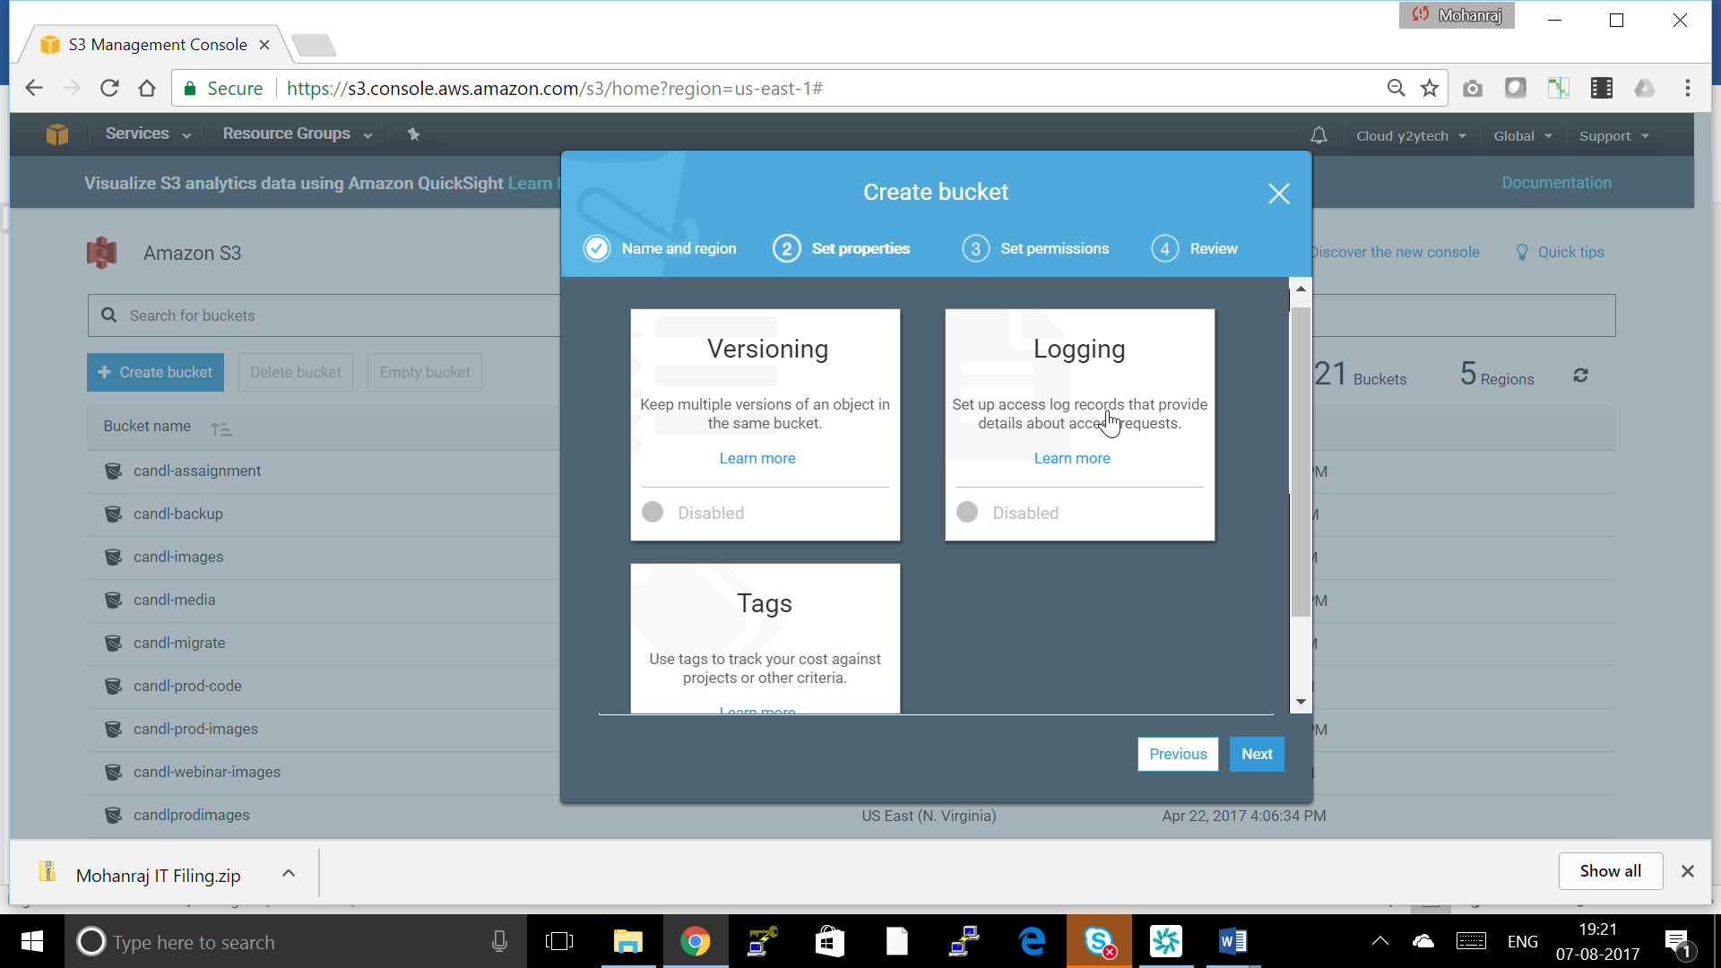

1. Enable logging and Select the Log bucket and put the path log need to be stored in log bucket Click **Save**.

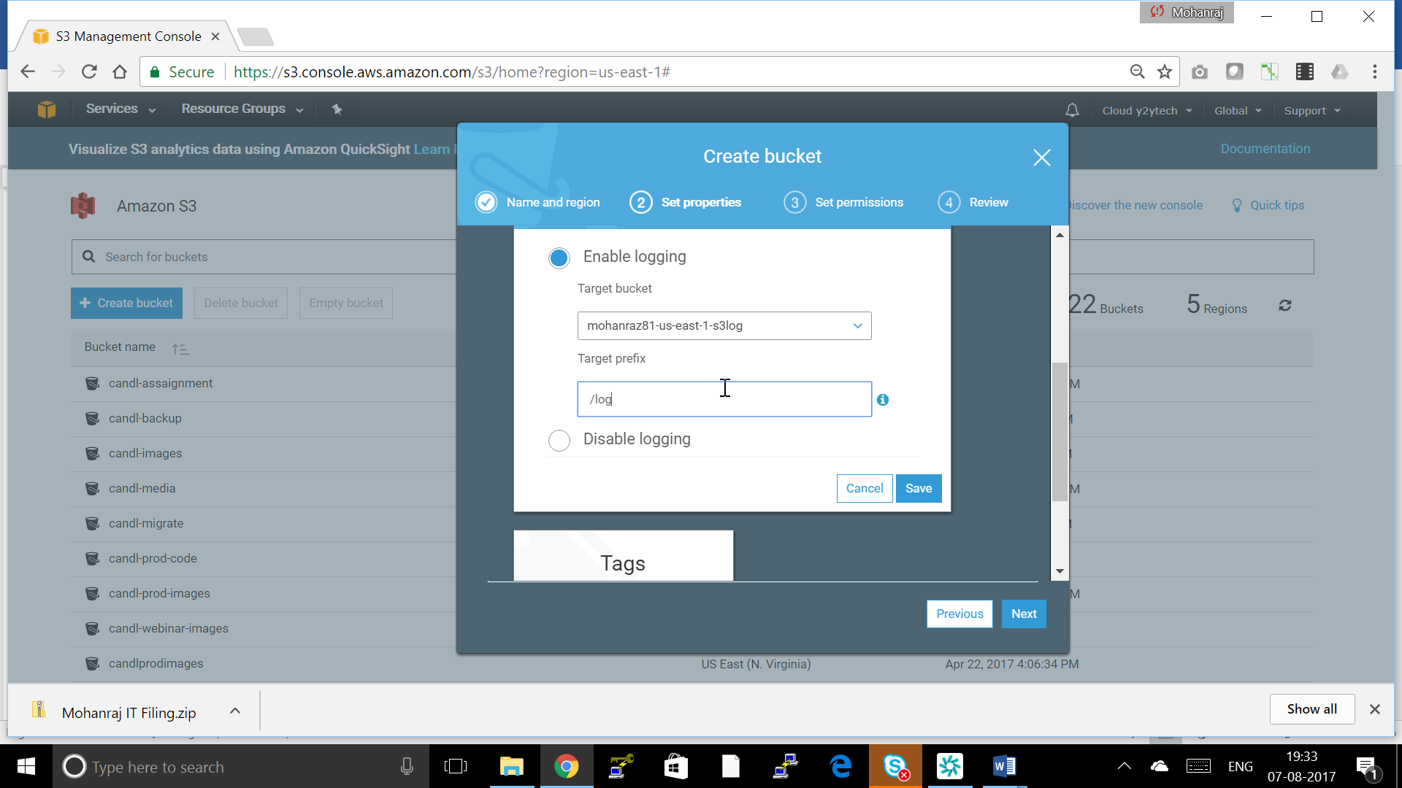

**Log File Format**

The server access log files consist of a sequence of new-line delimited log records. Each log record represents one request and consists of space delimited fields. The following is an example log consisting of six log records.

79a59df900b949e55d96a1e698fbacedfd6e09d98eacf8f8d5218e7cd47ef2be mybucket [06/Feb/2014:00:00:38 +0000] 192.0.2.3 79a59df900b949e55d96a1e698fbacedfd6e09d98eacf8f8d5218e7cd47ef2be 3E57427F3EXAMPLE REST.GET.VERSIONING - "GET /mybucket?versioning HTTP/1.1" 200 - 113 - 7 - "-" "S3Console/0.4" -

79a59df900b949e55d96a1e698fbacedfd6e09d98eacf8f8d5218e7cd47ef2be mybucket [06/Feb/2014:00:00:38 +0000] 192.0.2.3 79a59df900b949e55d96a1e698fbacedfd6e09d98eacf8f8d5218e7cd47ef2be 891CE47D2EXAMPLE REST.GET.LOGGING_STATUS - "GET /mybucket?logging HTTP/1.1" 200 - 242 - 11 - "-" "S3Console/0.4" -

79a59df900b949e55d96a1e698fbacedfd6e09d98eacf8f8d5218e7cd47ef2be mybucket [06/Feb/2014:00:00:38 +0000] 192.0.2.3 79a59df900b949e55d96a1e698fbacedfd6e09d98eacf8f8d5218e7cd47ef2be A1206F460EXAMPLE REST.GET.BUCKETPOLICY - "GET /mybucket?policy HTTP/1.1" 404 NoSuchBucketPolicy 297 - 38 - "-" "S3Console/0.4" -

79a59df900b949e55d96a1e698fbacedfd6e09d98eacf8f8d5218e7cd47ef2be mybucket [06/Feb/2014:00:01:00 +0000] 192.0.2.3 79a59df900b949e55d96a1e698fbacedfd6e09d98eacf8f8d5218e7cd47ef2be 7B4A0FABBEXAMPLE REST.GET.VERSIONING - "GET /mybucket?versioning HTTP/1.1" 200 - 113 - 33 - "-" "S3Console/0.4" -

79a59df900b949e55d96a1e698fbacedfd6e09d98eacf8f8d5218e7cd47ef2be mybucket [06/Feb/2014:00:01:57 +0000] 192.0.2.3 79a59df900b949e55d96a1e698fbacedfd6e09d98eacf8f8d5218e7cd47ef2be DD6CC733AEXAMPLE REST.PUT.OBJECT s3-dg.pdf "PUT /mybucket/s3-dg.pdf HTTP/1.1" 200 - - 4406583 41754 28 "-" "S3Console/0.4" -

79a59df900b949e55d96a1e698fbacedfd6e09d98eacf8f8d5218e7cd47ef2be mybucket [06/Feb/2014:00:03:21 +0000] 192.0.2.3 79a59df900b949e55d96a1e698fbacedfd6e09d98eacf8f8d5218e7cd47ef2be BC3C074D0EXAMPLE REST.GET.VERSIONING - "GET /mybucket?versioning HTTP/1.1" 200 - 113 - 28 - "-" "S3Console/0.4" -

**Note**

Any field can be set to "-" to indicate that the data was unknown or unavailable, or that the field was not applicable to this request.

The following list describes the log record fields.

**Bucket Owner**

The canonical user ID of the owner of the source bucket.

**Example Entry**

79a59df900b949e55d96a1e698fbacedfd6e09d98eacf8f8d5218e7cd47ef2be

**Bucket**

The name of the bucket that the request was processed against. If the system receives a malformed request and cannot determine the bucket, the request will not appear in any server access log.

**Example Entry**

mybucket

**Time**

The time at which the request was received. The format, using strftime() terminology, is as follows:[%d/%b/%Y:%H:%M:%S %z]

**Example Entry**

[06/Feb/2014:00:00:38 +0000]

**Remote IP**

The apparent Internet address of the requester. Intermediate proxies and firewalls might obscure the actual address of the machine making the request.

**Example Entry**

192.0.2.3

**Requester**

The canonical user ID of the requester, or the string "Anonymous" for unauthenticated requests. If the requester was an IAM user, this field will return the requester's IAM user name along with the AWS root account that the IAM user belongs to. This identifier is the same one used for access control purposes.

**Example Entry**

79a59df900b949e55d96a1e698fbacedfd6e09d98eacf8f8d5218e7cd47ef2be

**Request ID**

The request ID is a string generated by Amazon S3 to uniquely identify each request.

**Example Entry**

3E57427F33A59F07

**Operation**

The operation listed here is declared as SOAP.*operation*, REST.*HTTP_method*.*resource_type*,WEBSITE.*HTTP_method*.*resource_type*, or BATCH.DELETE.OBJECT.

**Example Entry**

REST.PUT.OBJECT

**Key**

The "key" part of the request, URL encoded, or "-" if the operation does not take a key parameter.

**Example Entry**

/photos/2014/08/puppy.jpg

**Request-URI**

The Request-URI part of the HTTP request message.

**Example Entry**

"GET /mybucket/photos/2014/08/puppy.jpg?x-foo=bar"

**HTTP status**

The numeric HTTP status code of the response.

**Example Entry**

200

**Error Code**

The Amazon S3 [Error Code](http://docs.aws.amazon.com/AmazonS3/latest/dev/ErrorCode.html), or "-" if no error occurred.

**Example Entry**

NoSuchBucket

**Bytes Sent**

The number of response bytes sent, excluding HTTP protocol overhead, or "-" if zero.

**Example Entry**

2662992

**Object Size**

The total size of the object in question.

**Example Entry**

3462992

**Total Time**

The number of milliseconds the request was in flight from the server's perspective. This value is measured from the time your request is received to the time that the last byte of the response is sent. Measurements made from the client's perspective might be longer due to network latency.

**Example Entry**

70

**Turn-Around Time**

The number of milliseconds that Amazon S3 spent processing your request. This value is measured from the time the last byte of your request was received until the time the first byte of the response was sent.

**Example Entry**

10

**Referrer**

The value of the HTTP Referrer header, if present. HTTP user-agents (e.g. browsers) typically set this header to the URL of the linking or embedding page when making a request.

**Example Entry**

"http://www.amazon.com/webservices"

**User-Agent**

The value of the HTTP User-Agent header.

**Example Entry**

"curl/7.15.1"

**Version Id**

The version ID in the request, or "-" if the operation does not take a *versionId* parameter.

**Example Entry**

3HL4kqtJvjVBH40Nrjfkd